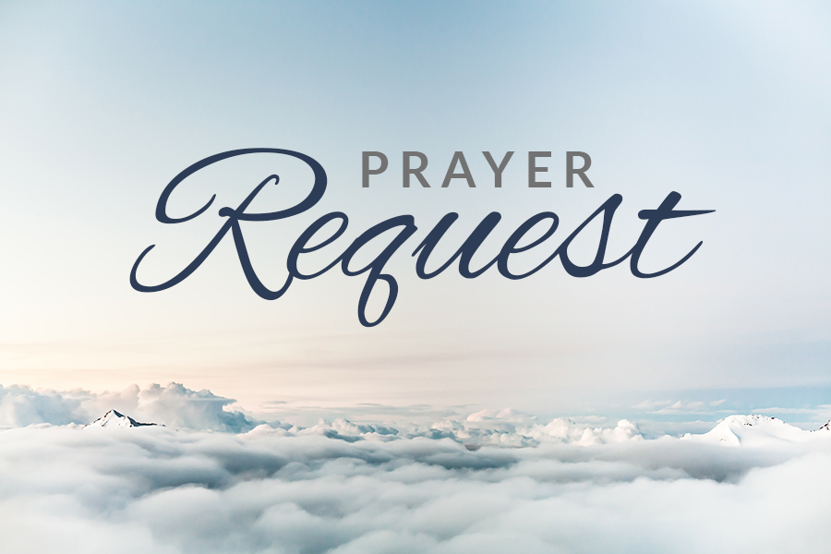

Those Remembered in prayer:

God of compassion be close to those who are ill, afraid or in isolation. In their loneliness, be their consolation; in their anxiety, be their hope; in their darkness, be their light; through him who suffered alone on the cross, but reigns with you in glory, Jesus Christ our Lord.

God’s guidance and protection for Armed Forces.

Mark Amyot, Donnie Baxter, Jim Beniot , Brad Bowers, Paige Bower, Chris Brant, Rhonda Brown, Ray Coleman, Susan Constantino, LaVern Coslic, Tammy Coughenour, Renee Croushore, Eric Custer, Lauren Davis, Tracy Dickey, Wilma Durst, Linda Gallick, Marlene Gotchen, Dennis Griffith, Karen Griffith, Mary Jane Harding, Andrea (Shaulis) Harris, Joe Harris, Joy Hay (Dwayne), Kris Hay, Larry Hay, Marilyn Heiple, Gary Hillegas, Cynthia Kelly, Barry Landis, Brenda Leister, Wendy Leister, Richard Lilliston, Jim Little, Blair and Phyllis Lyons, Debbie Luteri, Judy McCullen, Larrry McCullen, Joyce Miller, Robert Lee Miller, Carl (Edison) Paul, Kathy Picking, Lillian Potter, Easton Pritts, Brian Robb, James Robb, Brett Sarver, Lois Saylor, Tammie Saylor, Nancy Schrock, Curt Shaulis, Missy Shaulis, Drew Simmons, Dawn Edminston Strasser, Ron Tamblyn, Larry Tinkey, Patsy and Dave Titus, Barbara and Peter Usher, Faye Walker, Robin Walker, Nancy Weighley, Echo Kincaid Yoder, Gerald Zorn

