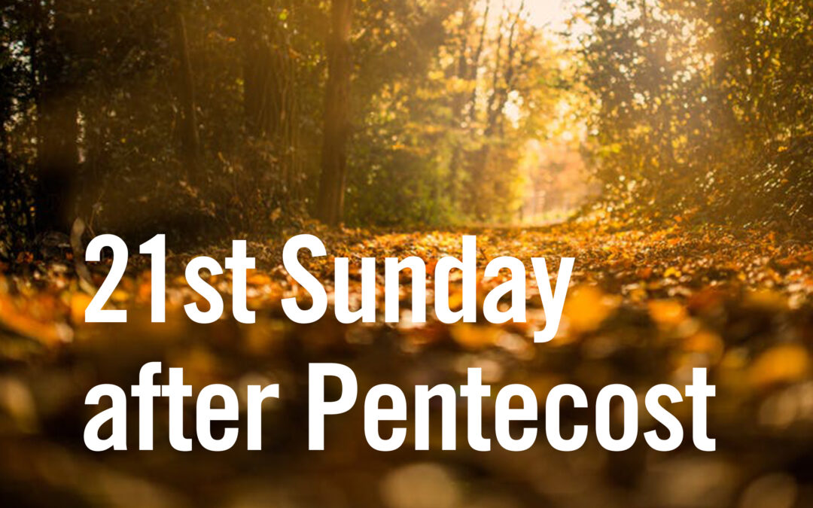

21st Sunday After Pentecost
October 18, 2026

Pastor Dave Creamer
Assisted By: Colton Custer

Trinity United Church of Christ
600 Main Street
Berlin Pennsylvania

“Please silence your cell phone”

Preludes:
Come Gracious Spirit, Heavenly Dove – Gilbert Martin
Dona Nobis Pacem with I Surrender All – Jeff Perks

Welcome

No matter who you are or where you are on life’s journey, you are welcome here at Trinity United Church of Christ.

Greeting and Announcements

*Hymn No. 96 All Hail the Power if Jesus Name

“Children’s Time”
Amanda Custer

Call to Confession

Isaiah Chapter 45 God assures us he open doors, break bars, and level Mountains. Through his Son Jesus Christ he can redeem souls. Let us go to God in Prayer.

Confession

Heavenly Father, hear our prayer. Forgive our ways that lead us astray. Redeem us with the Grace that Jesus Provides. Make us a people that do your will.

Silent Confession

Assurance of Pardon

Our God forms light, he creates darkness, his love saves. For these things we give God the Glory.

* Response 66 To God Be The Glory

To God be the glory great things He hath done! So loved He the world that He gave us His Son, Who yielded His life an atonement for sin And opened the Life gate that all may go in. Praise the Lord, Praise the Lord, Let the earth hear His voice, Praise the Lord, Praise the Lord, Let the people rejoice! O come to the Father thru Jesus the Son And give Him the glory great things He hath done.
*The Affirmation of Faith The Apostles Creed
I believe in God, the Father almighty,
creator of heaven and earth.
I believe in Jesus Christ, God’s only Son, our Lord,
who was conceived by the Holy Spirit,
born of the virgin Mary,
suffered under Pontius Pilate,
was crucified, died, and was buried.
He descended into hades.
On the third day he rose again;
he ascended into heaven,
he is seated at the right hand of the Father,
and he will come to judge the quick and the dead.
I believe in the Holy Spirit, the holy catholic Church,
the communion of saints, the forgiveness of sins,
the resurrection of the body, and life everlasting. Amen.

*Presentation of the Offering – Singing of the Doxology

Praise God from whom all blessings flow;
Praise him all creatures here below;
Praise him above ye heavenly host;
Praise Father, Son and Holy Ghost

Offertory Prayer
Heavenly Father, we humble ourselves before you. Blessed in many ways we share some of our gifts. We pray that your will is done with each offering. We ask for your guiding Spirt. We pray that surrounded by a world of distractions that you help us to know your will. Help us to do all the things that make us who we are in your Glory. We pray for the protective care of our military and our first responders. Keep them safe as they watch over us. We ask that you strengthen your church. That we may be the Body of Christ. Serving you in all our actions. We lift up to you our prayer list. Each name, each place, each concern, heal and comfort as only you can. We are grateful most of all for your Son Jesus Christ, our Savior and redeemer, through him all things are done. The prayer he first taught to us we offer to you;

The Lord’s Prayer (using debts and debtors)

The Hebrew Scripture lesson is from the
Profit Isaiah, Chapter 45, vs 1-7

1 Thus says the Lord to his anointed, to Cyrus,
whose right hand I have grasped,
to subdue nations before him
and ungird the loins of kings,
to open doors before him
that gates may not be closed:
2 “I will go before you
and level the mountains,
I will break in pieces the doors of bronze
and cut asunder the bars of iron,
3 I will give you the treasures of darkness
and the hoards in secret places,
that you may know that it is I, the Lord,
the God of Israel, who call you by your name.
4 For the sake of my servant Jacob,
and Israel my chosen,
I call you by your name,
I surname you, though you do not know me.
5 I am the Lord, and there is no other,
besides me there is no God;
I gird you, though you do not know me,
6 that men may know, from the rising of the sun
and from the west, that there is none besides me;
I am the Lord, and there is no other.
7 I form light and create darkness,
I make weal and create woe,
I am the Lord, who do all these things.

The Epistle lesson is from Paul’s Letter to the
Thessalonians, Chapter 1, vs 1-10
1 Paul, Silvanus, and Timothy, To the church of the Thessalonians in God the Father and the Lord Jesus Christ:
Grace to you and peace.
2 We give thanks to God always for you all, constantly mentioning you in our prayers,
3 remembering before our God and Father your work of faith and labor of love and steadfastness of hope in our Lord Jesus Christ.
4 For we know, brethren beloved by God, that he has chosen you; 5 for our gospel came to you not only in word, but also in power and in the Holy Spirit and with full conviction. You know what kind of men we proved to be among you for your sake.
6 And you became imitators of us and of the Lord, for you received the word in much affliction, with joy inspired by the Holy Spirit;
7 so that you became an example to all the believers in Macedonia and in Achaia.
8 For not only has the word of the Lord sounded forth from you in Macedonia and Achaia, but your faith in God has gone forth everywhere, so that we need not say anything.
9 For they themselves report concerning us what a welcome we had among you, and how you turned to God from idols, to serve a living and true God,
10 and to wait for his Son from heaven, whom he raised from the dead, Jesus who delivers us from the wrath to come.

The Gospel of Jesus Christ from the Book of
Matthew Chapter 22, vs 15-22

15 Then the Pharisees went and took counsel how to entangle him in his talk.
16 And they sent their disciples to him, along with the Herodi-ans, saying, “Teacher, we know that you are true, and teach the way of God truthfully, and care for no man; for you do not regard the position of men.
17 Tell us, then, what you think. Is it lawful to pay taxes to Caesar, or not?”
18 But Jesus, aware of their malice, said, “Why put me to the test, you hypocrites?
19 Show me the money for the tax.” And they brought him a coin. 20 And Jesus said to them, “Whose likeness and inscription is this?”
21 They said, “Caesar's.” Then he said to them, “Render therefore to Caesar the things that are Caesar's, and to God the things that are God's.”
22 When they heard it, they marveled; and they left him and went away.
Special Music
Danny Conner
Message
“Give God the things that are Gods”
Pastor Dave Creamer

*Hymn No. 26 A Mighty Fortress is Our God

*Benediction

*Response – Sung with Dismissal

Now Unto Him Who is Able

Now unto Him who is able to keep you from falling.
To make you stand in His presence blameless and with great joy. To the only God our Savior, Jesus Christ our Lord.
Be the glory, and the majesty, dominion, and authority.
Both now and forevermore, Amen

Going Forth

Postlude Jesus Shall Reign – Anna Laura Page

+ + + + + + +


Those Remembered in prayer:
God’s guidance and protection for Armed Forces.

Shut Ins:
Mary Jane Harding, Cynthia Kelly,
Debbi Luteri, Lillian Potter, Lois Saylor, Audrey Twombly
Healing Concerns:
Mark Amyot, Donnie Baxter, Paige Boyer,
Chris Brant, Rhonda Brown, Jeff Calvert, Debbie Chafin, Tim Clites, Susan Constantino, LaVerne Coslic, Tammy Coughenour, Pastor Dave Creamer, Eric Custer, Lauren Davis, Tracy Dickey,
Judy DiPasquale, Deneen Eutsey, Linda Gallick, Shirley Gary, Dennis Griffith, Karen Griffith, John Halverson, Andrea (Shaulis) Harris, Joe Harris, Michael Harris, Joy Hay (Dwayne), Larry Hay,
Marilyn Heiple, Gary Hillegas, Karen Hittie,
Barry Landis, Wendy Leister, Richard Lilliston, Jim Little,
Nick Lorson, Blair and Phylis Lyons, Judy McCullen,
Larry McCullen, Joyce Miller, Laura Miller, Robert “Lee” Miller, Tom Nicholson, Carl (Edison) Paul, Easton Pritts, Brian Robb, James Robb, Brett Sarver, Kayla Sarver, Tammie Saylor,
Nancy Schrock, Curt Shaulis, Missy Shaulis,
Dawn Edmiston-Strasser, Chuck Sullivan, Larry Tinkey,
Lilly Truszka, Barbara and Peter Usher,
Carl & Matthew Walker, Faye Walker,
Robin Walker, Nancy Weighley,
Echo Kincaid Yoder

If you have any information on anyone on this list, please contact the office with updates.

The Saints In Action

TODAY- 21st Sunday after Pentecost
9:00 a.m. Worship
10:10 a.m. Sunday School
VBS Sunday School – Children’s Time

Monday – Consistory Meeting 6:30 p.m.

Wednesday – Trinity Bells 6:30 p.m.

Next Sunday 22nd Sunday after Pentecost
9:00 a.m. Worship
10:10 a.m. Sunday School

Where You May Find. . .
The Nursery: is on the lower level for children and their parent. A big screen TV is mounted in the room so that you may watch the service.
At the Sanctuary Entrances. . .
Large Print Bulletins Hearing Amplifiers
Recycling Boxes for Bulletins These Days – Devotional
Assisting in Worship

Sound: Jim and Jean Ann Darr
Ushers: Bill Landis, Jim Walker
Acolyte / Lector: Colton Custer
Organ: Ann Slifco

Flowers on the altar are in loving memory of her Mother Ruth Romesberg’s birthday (10/24) by Larry & Gale Hay

The Whole Congregation in Ministry and Assisted by

Dave Creamer, Pastor
Church Secretaries: Pam Bush, Jean Ann Darr
Financial Secretary: Renee Gindlesperger
Chancel Choir Director Emeritus: Linda Gallick
Handbells: Jeanne Hillegas
Virtual Organist: Rick Kimmel

Consistory Elders:
Sue Coughenour, 814-233-5413
Jim Darr, 814-483-0957
Allison Zimmerman, 814-267-4324
Consistory Deacons:
Pam Bush, Lori Gindlesperger, Jean Hart, Jeanne Hillegas,
Bill Landis (President) 814-521-6800, Allen Strasser, Amy Saylor, Carrie Croner, Shawn Hart

Church Office Hours – Tuesday through Thursday
9:00 a.m. to 1 p.m.
Church Office Phone: 814-267-3234
Mailing Address: PO Box 86, Berlin, PA 15530
Email: berlinucc@yahoo.com Website: www.berlinucc.org

All Saints Sunday – November 8th

Veterans Sunday – November 15th
If there are any changes or additions to the veterans or those currently in the military, please contact Sheron Engleka at 814-267-4166 by October 25th. Thank you.

Adult Sunday School Update:
In Revelation 2 & 3, Jesus dictated, through John, seven letters to seven pastors in Asia Minor, which is modern day Turkey. While the churches were literal, they each also represented a specific time in church history leading up to Christ’ second coming. God had a specific message for each church and each period of church history.
Join the Adult Sunday school class on Sunday, September 20, 2026, as we begin a deep look into these two chapters in Revelation. Adult Sunday school begins at 10:10 am in the Fellowship Hall and all are welcome. If you have any questions, please contact Sue Coughenour.

VBS Sunday School - Today
The next VBS Sunday School will be on October 18th, "When life is unfair... God is Good" Come join us for a lot of fun, learning, snacks, games, crafts and more!!

Lego Sunday School
This year we will be having a Lego Sunday School lesson on the 4th Sunday of the month. We will be teaching the parables using Legos. There will be singing, games, hands-on activities and a snack. Come join us as we learn about Jesus!

Junior / Senior High Sunday School
Junior / Senior High Sunday School will meet every Sunday. We will be participating in the VBS Sunday School on the 3rd Sunday and the Lego Sunday School on the 4th Sunday of the month.
On the other Sundays, we will be studying our faith in Jesus and how to defend it (talk about it to others or apologetics). Please join us as we study how history and science prove Jesus.

Hugs & Kisses
Friday, November 20th 5 PM- Game Night at the church. H&K will provide pizza and those attending can bring snacks and drinks to share. This is for ALL ages, so bring your favorite board games and join us for fun and fellowship. Watch for a sign-up sheet so we know how much pizza to purchase.

Trinity Ladies
Our next meeting will be Monday, November 2 at 11:30 a.m. at Cup of Soul. Come join us as we serve the Lord and fellowship together!

TODAY!
Camp Living Waters Workday
Mark your calendars for November 7th at 8:00 a.m. to join everyone at Camp Living Waters workday preparing for the winter season. All assistance is appreciated.

Gingerbread House Contest 🎄🏠
The Pius Spring Women’s Club invites you to join our Gingerbread House Contest on November 21st! Individuals, families, friends, businesses, organizations, and groups are welcome to enter. Entry fee is $25, and entry forms are due November 1st. Prizes will be awarded.
Build it. Decorate it. Enter it. Let the community decide! ❤️💚
Contact Lori Gindlesperger for application, gind1990@verizon.net

St. Paul’s Lutheran Church in Stoystown will be hosting an Herbal Cold Care class on Thursday, October 22nd at 7:00 p.m. Learn how to make fire cider, an immune boosting tincture, a tea for coughs and congestion and more. Please text Jess Weaver at 814-483-4817 to register or if you have questions.

St. Paul’s will also be hosting an Apple Dumpling Social on November 7th from 4:00-7:00 p.m. at 6872 Lincoln Hwy, Stoystown. Takeout Soup and Apple Dumplings will be available by preorder only. Quarts of Ham Pot Pie, Vegetable Beef, Chicken Noodle, or Chili for $9.00. Apple Dumplings 2/$8.00. Contact Michelle at 814-442-9881 or mkimmel@comcast.net by October 31st to order. Pick up from 2:00-4:00 November 7th.

Pastoral Care: For those in need of pastoral care please contact Pastor Dave Creamer at 814-777-2280. If Dave is not available, please contact Tom Croner at 814-442-6740. If neither is available, contact Pam Bush at 541-990-0832.

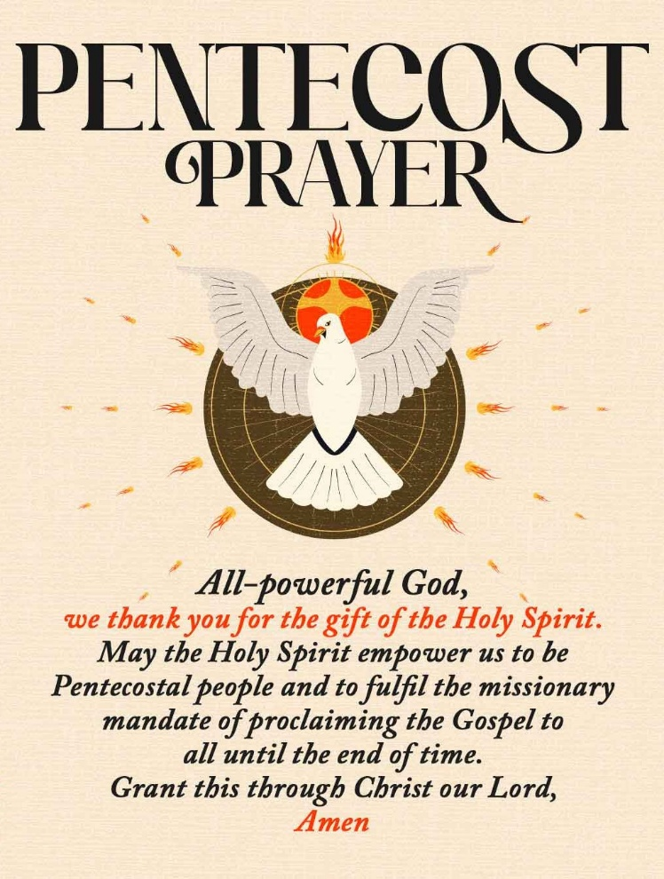

Holy and gracious God,
On this Twenty‑First Sunday after Pentecost, we come before you seeking wisdom, courage, and clarity. You call us to follow Jesus with open hearts, yet we confess how easily we cling to the comforts and possessions of this world. Free us from whatever keeps us from fully trusting you.
In Jesus’ name we pray. Amen.

Thank You For Joining Us
& Have A Blessed Week Ahead
God Bless You All

